排版参考对应栏链接内容：

Two component 2K injection molding of handle switches标题 加对应视频1条 图片1.2.3.、

AnsixTech’s two component 2K mold manufacturing process and two component material injection molding process for plastic handle buttons is an advanced manufacturing method used to produce plastic handle buttons with a two-color effect. As a leading plastic manufacturer, AnsixTech is committed to providing high-quality and innovative products. Two-color mold manufacturing and two-color material injection molding processes are one of the keys to its success.

Double color mold manufacturing process:

In AnsixTech’s two-color mold manufacturing process, first, a team of experienced engineers uses CAD software to design the model of the plastic handle buttons. Based on the design requirements of the AnsixTech handle, they determined what components and colors the buttons need to be divided into, and determined the location of the dividing lines and interfaces. They then use advanced manufacturing equipment and technology to create two-color injection molds. These molds usually consist of two injection molds, one for injection molding materials of different colors. When manufacturing two-color molds, AnsixTech focuses on the structure and runner design of the mold to ensure that the two-color materials can be accurately injected and form the expected two-color effect. They also conduct strict mold testing and debugging to ensure the quality and performance of the molds.

Two-color material injection molding process:

AnsixTech uses advanced two-color material injection molding technology and combines two-color molds with injection molding technology. First, they choose high-quality two-color injection molding materials, and determine the color and hardness according to the requirements of the handle buttons. These materials are rigorously screened and tested to ensure they meet AnsixTech’s quality standards. They then heated each of the two colors of material until they melted. Utilizing an advanced two-color injection molding machine, AnsixTech injects two colors of molten material into the mold so that it fills the mold’s cavity. The injection molding machine has a precise control system that can accurately control the injection ratio and injection time of the two color materials to ensure the accuracy and consistency of the two-color effect. During the injection molding process, AnsixTech strictly controls injection molding parameters to ensure product quality and performance.

Through the two-color mold manufacturing process and two-color material injection molding process of AnsixTech plastic handle buttons, the two-color effect of the buttons can be achieved, increasing the product’s appearance appeal and market competitiveness. Two-color injection molding can also improve the quality and durability of the buttons to meet the needs of different users. AnsixTech is committed to continuous improvement and innovation, and continues to improve the technical level of two-color mold manufacturing and two-color material injection molding processes to meet market needs. Their professional team will continue to work hard to provide customers with high-quality, innovative and reliable plastic handle button products.

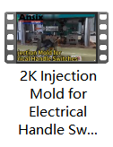 <https://youtu.be/gm4MaEPCy_8> 链接视频

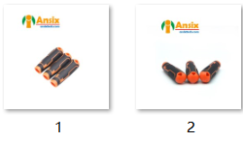 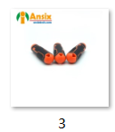

|  |  |
| --- | --- |
| **Mold Description** | |
| Product Materials: | ABS/PC  Soft rubber: TPR |
| Mold Material: | S136ESR |
| Number of Cavities: | 4+4 |
| Glue Feeding Method: | Hot runner |
| Cooling Method: | Water cooling |
| Molding Cycle | 21.5s |

Mold Marking Process:

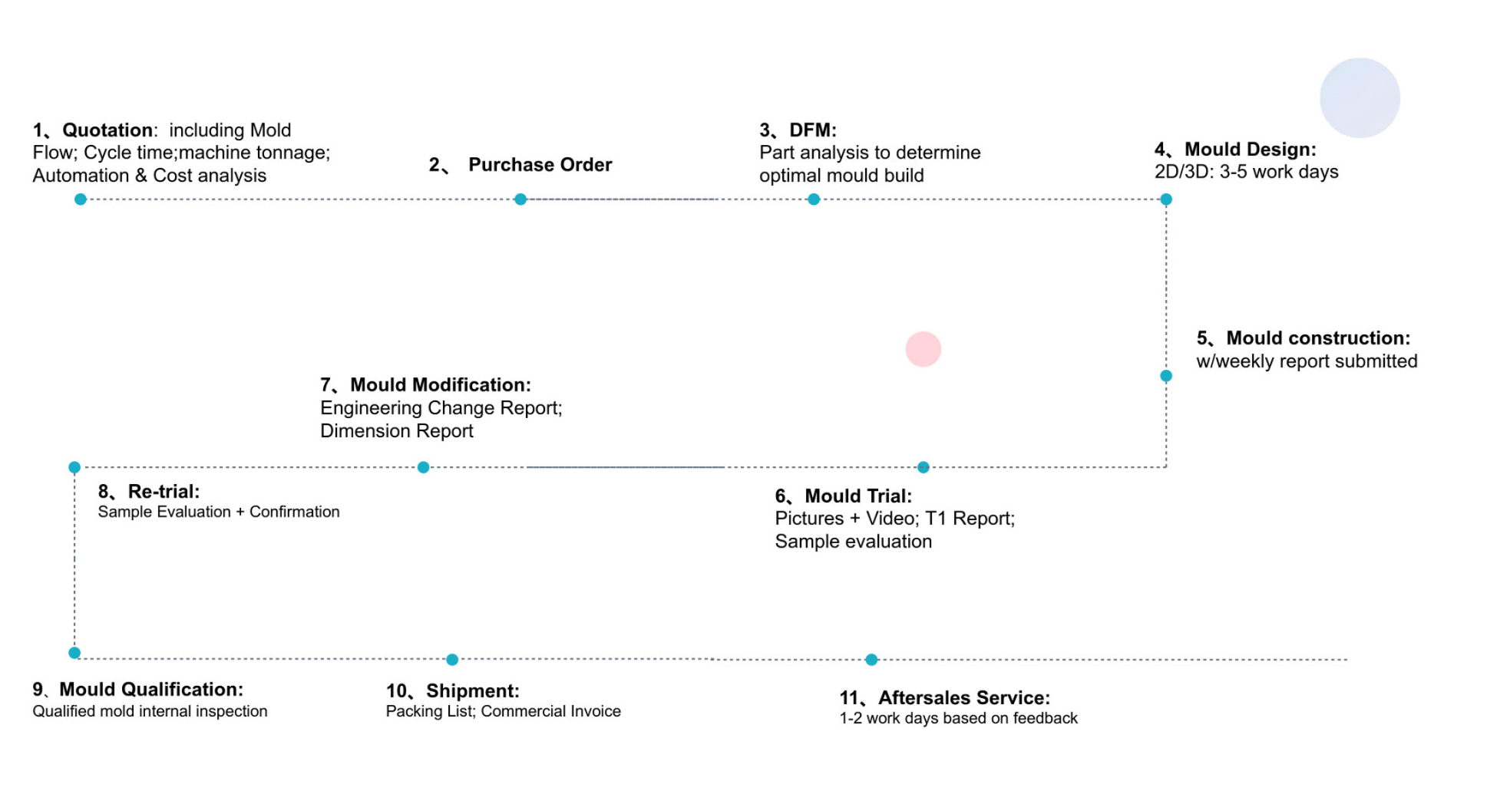

Mold flow analysis and mold design 标题 图5

Mold flow analysis and mold design of are key steps to ensure product quality and production efficiency.

Mold flow analysis:

a. Collect design data of plastic products, including size, shape, wall thickness, etc.

b. Establish a three-dimensional model of the plastic product and import it into the mold flow analysis software.

c. Set injection molding process parameters, such as injection temperature, injection pressure, injection speed, etc.

d. Conduct mold flow analysis to simulate melt flow, filling, cooling, etc. during the injection molding process.

e. Analyze mold flow results, evaluate filling conditions, bubbles, short shots and other defects, and make suggestions for improvement.

Mold design:

a. Optimize the mold structure and design based on the mold flow analysis results. For example, the shape and size of the mold cavity and mold core are adjusted to improve filling performance and cooling effects.

b. Design a suitable filling system, including plastic inlet, diversion system, etc., to ensure that the plastic can fully fill the mold cavity.

c. Design a suitable cooling system to improve the dimensional stability and quality of the product. Optimize the layout and design of the cooling system to improve cooling effectiveness.

d. Design a suitable demoulding system, including ejector pins, ejection devices, release agents, etc., to ensure that plastic products can be demoulded smoothly.

e. Conduct strength and stiffness analysis of the mold structure to ensure that the mold can withstand the pressure and stress during the injection molding process.

f. Improve the mold details, such as cooling water holes, exhaust holes, positioning pins, etc., to improve the service life and stability of the mold.

Through mold flow analysis and mold design, the injection molding process and mold structure of plastic products can be optimized to improve product quality and production efficiency.



The mold manufacturing process and product material selection 标题 图77

The mold manufacturing process and product material selection of plastic products are key factors to ensure product quality and production efficiency.

Mold manufacturing process:

a. Mold design: Design the mold according to the shape, size and requirements of the plastic product. Mold design includes mold structure design, filling system design, cooling system design, demoulding system design, etc.

b. Material preparation: Select suitable mold material, such as tool steel or stainless steel. According to the mold design, prepare the required materials, including mold base plate, mold cavity, mold core and other parts.

c. Processing mold parts: Process mold parts according to the mold design. Including cutting, milling, drilling, turning and other process operations to manufacture various parts of the mold.

d. Heat treatment: Heat treatment of mold parts to improve the hardness and wear resistance of the material. Common heat treatment methods include quenching, tempering, etc.

e. Assemble the mold: Assemble the processed mold parts, including the assembly of the mold base plate, mold cavity, mold core and other parts. Ensure the accuracy and stability of the mold’s structure and size.

f. Debugging and mold trial: Carry out debugging and mold trial on the assembled mold. Use the injection molding machine to test the mold, observe and detect the filling performance of the mold, the size and quality of the product, etc.

g. Surface treatment: Surface treatment of the mold to improve the corrosion resistance and appearance quality of the mold. Common surface treatment methods include electroplating, spraying, etc.

h. Mold maintenance and upkeep: During the use of the mold, clean, lubricate and maintain the mold regularly to extend the service life of the mold. Reasonably arrange the replacement and repair of molds based on production volume and usage.

Product material selection:

a. Injection molding material: Select the appropriate injection molding material according to the requirements of the plastic product and the application environment. Common plastic materials include ABS,PP,PC,ABS/PC,PBT,PMMA,SAN,PA,PA66,PA6,POM,PET,PE,PVT,TPE,TPR,SILICONE,PEEK,PEI,PS,PES,PI,PPSU,PETG,PCTG,PFA,NBR,PTFE,PAEK,PAA,PEAA etc. According to the characteristics and requirements of the product, select materials with appropriate hardness, wear resistance, chemical resistance and other properties.

Mold material selection:

The selection of mold materials should take into account the shape, size and requirements of the plastic product, as well as the service life and production volume of the mold. Common mold materials include tool steel, stainless steel,738、2738H 、718、718H、NAK80、2083、2316、2344、2083H、2316H、S136、S136H、S136-D、HPM38、M300、S-STAR、M333、S196 etc., which have high hardness and wear resistance.

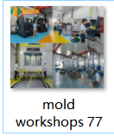

**Mass production and Quality control 标题 放视频1条 名 Automotive**

**Mass production and quality control are the keys to ensuring product quality and production efficiency.**

**Production planning and scheduling: Develop detailed production plans, including production time, quantity, delivery date, etc. According to the production plan, reasonably arrange production tasks and resources to ensure that production tasks are completed on time.**

**Injection molding process control: Establish strict injection molding process control, including the control of injection temperature, injection pressure, injection speed and other parameters. Through real-time monitoring and adjustment of process parameters, the dimensional accuracy and appearance quality of the product are ensured.**

**Raw material control: Strictly control the quality and source of raw materials. Work with reliable suppliers to ensure raw materials meet product requirements and standards. Conduct inspection and testing of raw materials to ensure stable quality of raw materials.**

**Production process control: Use statistical process control (SPC) methods to monitor and analyze the production process in real time. By collecting and analyzing data, abnormalities and variations in the production process are discovered and corrected in a timely manner to ensure the stability and consistency of product quality.**

**Inspection and testing: Inspection and testing are carried out during the production process, including raw material inspection, process inspection and finished product inspection. Use appropriate testing equipment and methods to test the size, appearance and function of the product to ensure that the product meets the requirements.**

**Capacity planning and scheduling: Capacity planning and scheduling are carried out according to customer needs and delivery time. Arrange production plans reasonably to ensure production tasks are completed on time.**

**After-sales service and customer feedback: Establish a sound after-sales service and customer feedback mechanism to handle customer problems and needs in a timely manner. Through customer feedback, understand product usage and quality issues, and make timely improvements and corrections.**

**Continuous improvement: Improve production efficiency and product quality through continuous improvement and optimization of the production process. Adopt advanced technology and processes, introduce automation and intelligent equipment, and improve the stability and consistency of production.**

**At the same time, the production process is continuously improved and optimized to improve production efficiency and product quality. Ensure on-time delivery to customers and provide satisfactory after-sales service and support.**

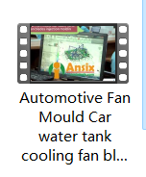

Why Choose AnsixTech Custom Plastic Injection Services? 标题 图88

AnsixTech Manufacturing capacity

AnsixTech has four production bases in China and Vietnam. We have a total of 260 injection molding machines. The tonnage of injection molding machines ranges from the smallest 30 tons to 2800 tons. The main injection molding machines include Japan's Fanuc, Sumitomo, Toshiba, Nissei, and Germany's Arburg (mainly liquid silicone injection molding, mainly two component). China has Haitian and Victor Taichung Machinery, etc.

AnsixTech is mainly engaged in the fields of medical equipment, automotive interior molds, automotive interior decoration (INS/TOM/DOD), household appliances, daily necessities, kitchenware series, 3C, consumer electronics, industrial control appliances, maternal and infant products, etc.

Advanced equipment: AnsixTech factory has advanced injection molding equipment, mold manufacturing equipment and processing equipment. our use the latest technology and equipment to ensure efficiency and quality of the production process.

Production capacity: AnsixTech factory has strong production capacity and can meet customers’ mass production needs. our have efficient production lines and processes that enable them to quickly respond to customer orders and deliver on time.

Quality Control: AnsixTech factory attaches great importance to quality control.our have a strict quality management system, including quality control and inspection from raw material procurement to production process. our use advanced testing equipment and methods to ensure that the quality of their products meets customer requirements and standards.

Technical team: AnsixTech factory has a professional technical team, including engineers, technicians and quality control personnel. our have rich experience and professional knowledge and can provide technical support and solutions to ensure the smooth progress of the production process and the quality of the products.

Environmental management: AnsixTech factory focuses on environmental protection and sustainable development. our comply with environmental regulations and standards and take steps to reduce their impact on the environment, such as waste disposal and energy management.

Supply chain management: AnsixTech factory has good supply chain management capabilities. our have established long-term cooperative relationships with reliable suppliers to ensure the quality of raw materials and the stability of supply. our also work with logistics companies to ensure timely delivery of products and efficient logistics.

Innovation capability: AnsixTech factory focuses on innovation and technological progress. our continuously research and develop new materials, processes and technologies to provide better products and solutions. our actively participate in industry seminars and exhibitions, communicate and share experiences with experts in the same industry, and continuously improve their innovation capabilities and competitiveness.

AnsixTech factory relies on its advanced equipment, strong production capacity, strict quality control, professional technical team, environmental management, supply chain management and innovation capabilities to provide customers with high-quality, efficient and reliable products and services. Serve. They are committed to working with customers to jointly promote the development and progress of the industry.

Professional experience: AnsixTech has many years of experience in precision plastic injection services and is very familiar with the needs and standards of the control industry. our are able to provide high-quality injection services and ensure product safety and reliability.

Advanced equipment: AnsixTech has advanced injection equipment and technology, which can meet various complex injection needs. our constantly update their equipment and technology to ensure they can provide the latest solutions.

Quality control: We have the international medical certification ISO9001/ISO13485/IATF16949 system, and have obtained an ISO 8 Cleanroom and GMP, which complies with the US medical grade FDA510K standard, and strictly implements it in accordance with the standards.AnsixTech focuses on quality control, and they adopt a strict quality management system to ensure that each product meets relevant standards and requirements. our conduct rigorous inspection and testing to ensure product quality and performance.

AnsixTech can effectively control costs and improve the company’s competitiveness and profitability. our focus on supply chain management, production process optimization, energy and resource conservation, overhead control and quality management to reduce costs in many aspects.

Customer customization: AnsixTech can provide customized injection services according to customer needs. our work closely with customers to understand their needs and requirements and provide solutions accordingly.

Quality service: AnsixTech focuses on customer service, they provide timely and professional technical support to ensure customer satisfaction. our are able to respond quickly to customer needs and provide solutions.

Choosing AnsixTech plastic injection services can provide you with professional experience, advanced equipment, high-quality services and customized solutions to ensure product quality and performance.

Cost control:

1.Supply chain management: AnsixTech establishes long-term cooperative relationships with suppliers and conducts effective supply chain management. our negotiate with suppliers for better prices and preferential terms, thereby reducing the purchase cost of raw materials and equipment. In addition, our regularly evaluate supplier performance to ensure the stability and efficiency of the supply chain.

2.Production process optimization: AnsixTech improves production efficiency and reduces production costs by optimizing the production process. our reduce labor and time costs through refined management and automated equipment. our also regularly evaluate and improve production processes to increase efficiency and reduce costs.

3.Save energy and resources: AnsixTech focuses on saving energy and resource use, and reduces the waste of energy and resources through the use of efficient equipment and processes. our have also adopted recycling and reuse measures to reduce the cost of waste disposal. In addition, our regularly evaluate and improve energy and resource usage to further reduce costs.

4.Management expense control: AnsixTech reduces management expenses through refined management and control of various expenses. They conduct strict budgeting and monitoring of various expenses to ensure the rationality and effectiveness of expenses. our also regularly evaluate and optimize overhead expenses to further reduce costs.

5.Quality management: AnsixTech focuses on quality management and reduces the cost of after-sales service and returns by improving product quality and reducing the rate of defective products. our conduct strict quality control and testing to ensure that products meet standards and requirements. our also regularly evaluate and improve quality management to further reduce costs. If you have any questions about products in the plastic molding and mold field, please send us a message(Email: [info@ansixtech.com](mailto:info@ansixtech.com) ) at any time and our team will reply to you within 12 hours.

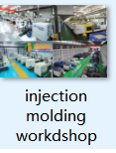

FAQ

How long does it take for each stage to work after the mold contract is signed?

1. After signing the contract, there will be 3-4 days to check with the customer first, and the two parties will communicate some specific requirements of the mold;

2. The mold design time is about 5-7 days, and material procurement will be carried out in the same period;

3. The mold production time is about 20-35 days, which varies according to the size and complexity of the mold;

4. The mold trial and inspection time is about 2-3 days;

5. After the T1 mold test, the mold perform is about 3-5 days, and then the T2 mold test is performed again. Generally, there are 3 mold tests to basically meet the requirements.

How can I get the quotation?

We will prepair the quotation in 24 hours if getting detailed information during working days.In order to quote for you earlier, please provide us the following information together with your inquiry.

1) 3D date and 2D Drawings

2) Material requirement

3) Surface requirment

4) Quantity (per order/per month/annual)

5) Any special demands or requirements, such as packing, labels, delivery, etc.

How do you ensure the quality of the mold?

1. We have a high level "Mold Inspection Standard", a complete set of strict mold inspection system and an excellent inspection team.

2. We can provide inspection reports and purchase certificates for all materials of the mold.

Does your company provide product design services?

1. Absolutely. We have support many clients from Europe and North America develement their new products.

2. You only need to provide requirements, your requirements can be a picture or a few sketches, our engineers can connect with you.

3. We will sign the "Confidentiality Agreement for Entrusted Product Design" and "Intellectual Property Agreement" with you.

How is your after-sales service and local support maintenance?

1. We have after-sales service points or mold cooperative manufacturers in Europe, North America and South America.

2. We will participate in international key exhibitions every year. Euromold, Fakuma, Formnext, NPE are the important exhibitions we often attend. Customers can meet us at the exhibition site. After the exhibition, we will visit local customers.

3. We have a professional after-sales service team, which will visit customers at least once a year and make some maintenance work.