GYS102J全液压振动
GYS102J FULL HYDRAULIC SINGLE DRUM
VIBRATORY ROLLER
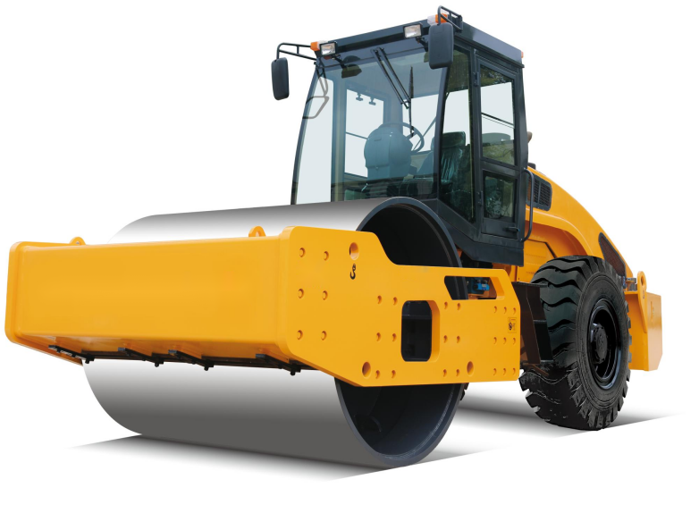

规格型号：GYS102J型振动压路机
MODEL: GYS102J FULL HYDRAULIC SINGLE DRUM VIBRATORY ROLLER
主要性能特点：Main characteristic
适用于高等级公路、大坝、铁路、机场等大型工程基础的压实，可碾压砂土、砾石、碎石、岩石填方等非粘性材料及半粘性材料。。
Suitable for compaction of foundations for large-scale engineering projects such as expressways, dams, railways, and airports, capable of compacting non-cohesive materials and semi-cohesive materials such as sandy soil, gravel, crushed stone, and rock fill.
性能特点：
1、液压双轮驱动，两档无级变速，爬坡性能好；
Hydraulic two-wheel drive, two-speed continuously variable speed, good climbing performance.
2、液压振动，双频双幅，电控起振；
Hydraulic vibration, dual-frequency double amplitude, electronically controlled vibration.
3、液压转向，铰接式车架，操作轻便灵活；
Hydraulic steering, articulated frame, light and flexible operation.
4、压路机专用驱动桥，驱动性能优越；
Equipped with a special drive axle for road rollers, offering superior drive performance.
5、液压行走制动，电控盘刹停车制动；
Hydraulic traveling brake, electronically controlled disc brake parking brake.
- 后机罩可大角度开起，维护保养触手可得；
The rear cover can be opened at a large angle, making maintenance and servicing easily accessible..
7、驱动和振动系统均配置进口国际知名品牌液压元件，性能可靠
Equipped with imported international famous brand hydraulic components, reliable performance.
8、标配驾驶室选配冷暖空调；
Standard cab , A/C optional .
主要技术参数：Main parameters
1、整机重量 Operating weight | 10000 kg
2、振动轮直径 Drum Diameter | 1450 mm
3、压实宽度 Compaction width | 2100 mm
4、静线载荷 Static line pressure | 255 N/cm
5、振动频率 Vibratory frequency | 30/35 Hz
7、理论振幅 Vibratory amplitude | 1.8/0.9 mm
8、激振力 Centrifugal force | 250/160 kN
9、行驶速度 Travelling speed | 0-5，0-9 km/h
10、爬坡能力 Gradeability | 50%
11、转弯半径 Min. turning radius | 6200 mm
12、轴距 Wheel base | 3000 mm
13、最小离地间隙 Min. ground clearance | 380 mm
14、外形尺寸（长×宽×高）  Dimension (L×W×H) | 5850×2250×3010mm
15、发动机 Engine
型 号 Model | WP4G110E220
功 率 Rated power | 82 kW
转 速 Rated speed | 2200 r/min
16、燃油箱 Fuel tank | 240 L
17、液压油箱 Hydraulic oil tank | 190 L
主要配置说明 Main configuration
序号  S/N | 名 称  ITEM | 规格型号  MODEL | 数量  NO. | 制造商  MANUFACTURER
1 | 柴油机  Engine | WP4G110E220 | 1 | 潍柴  WEICHAI
2 | 振动泵  Vibratory pump | HPV055 | 1 | 林德  LINDE
3 | 振动马达  Vibratory motor | HMF055 | 1 | 林德  LINDE
4 | 驱动泵  Travelling pump | HPV075 | 1 | 林德  LINDE
5 | 钢轮马达  Drum motor | HMF055 | 1 | 林德  LINDE
6 | 驱动马达  Travelling motor | HMV055 | 1 | 林德  LINDE

