USB&WiFi Handheld Ultrsound Scanner
(For Cosmetic Facial Plastic Surgery)
Model: Airscan Faci6
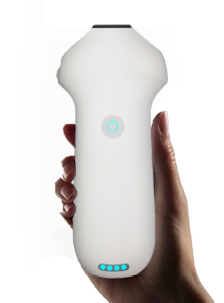
Features：
- It used for Mapping & Injection, evaluating filler.
- Lighter and smaller (only 155g) easy to carry.
- Full waterproof design, IPX8 convenient for sterilization.
-USB&WiFi two connections
-Support working while charging
-Free App, no membership fee, support IOS/Android/Windows.
-Built-in cooling coating
-Software feature:
√Support Dicom
√ Report edit/print
√ Free app & updates, Unlimited users
√ Horizontal&Vercal Screen display
√ Dual-screen display in different modes

Specification:
Index | Contents
Model Name | Airscan Faci6
Type | USB&WiFi Handheld Ultrsound Scanner
Application | Cosmetic Facial Plastic Surgery
Frequency | 16-20Mhz
Scan Depth | 10-40mm
Elements | 192
Display Mode | B.B+M.Color.PW. PDI
Channe | 6
Image Management | JPEG, MP4, Dicom ,Save&Share,image/video/report
Connection | USB&WiFi
System Support | Android. IOS. Windows
Devic Support | Android :Tablet/Phone/TV  IOS :Ipad/iPhone (only WiFi)  Windows PC
Battery Capacity | 2200 mAh
Battery Working time | 3h, 48h Ultra-long standb
Recharge time | 2~3h by  USB cable or wireless chargin
Adjustable Parameters | B/Color GN(Gain)  D(Depth)  ENH(Enhancement)  DR(Dynamic Range)  H(harmonic)  Focus  8 TGC  Mid-Line  An note  Biopsy Puncture  Page Left/Right Up/Down
Dimensions | 155x65x25mm
Weight | 155g

Image:
medial canthal artery near nose
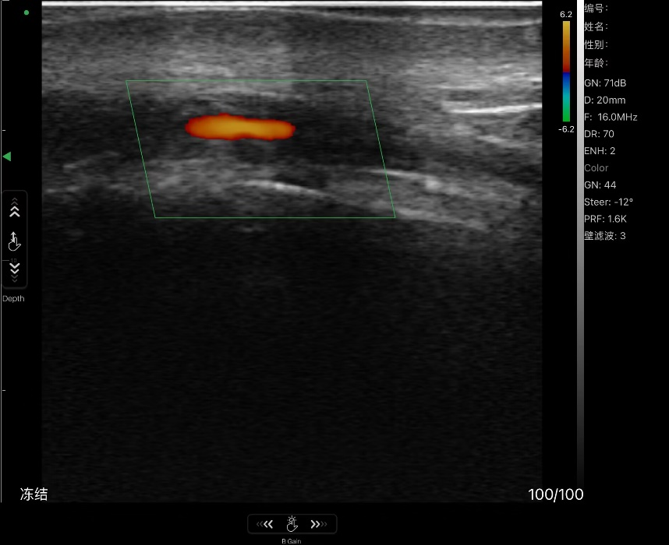

superior labial artery
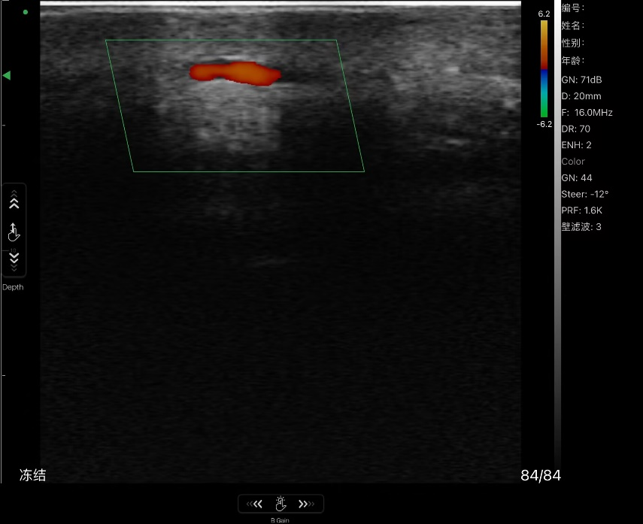

Zygomaticorbital artery near the eye
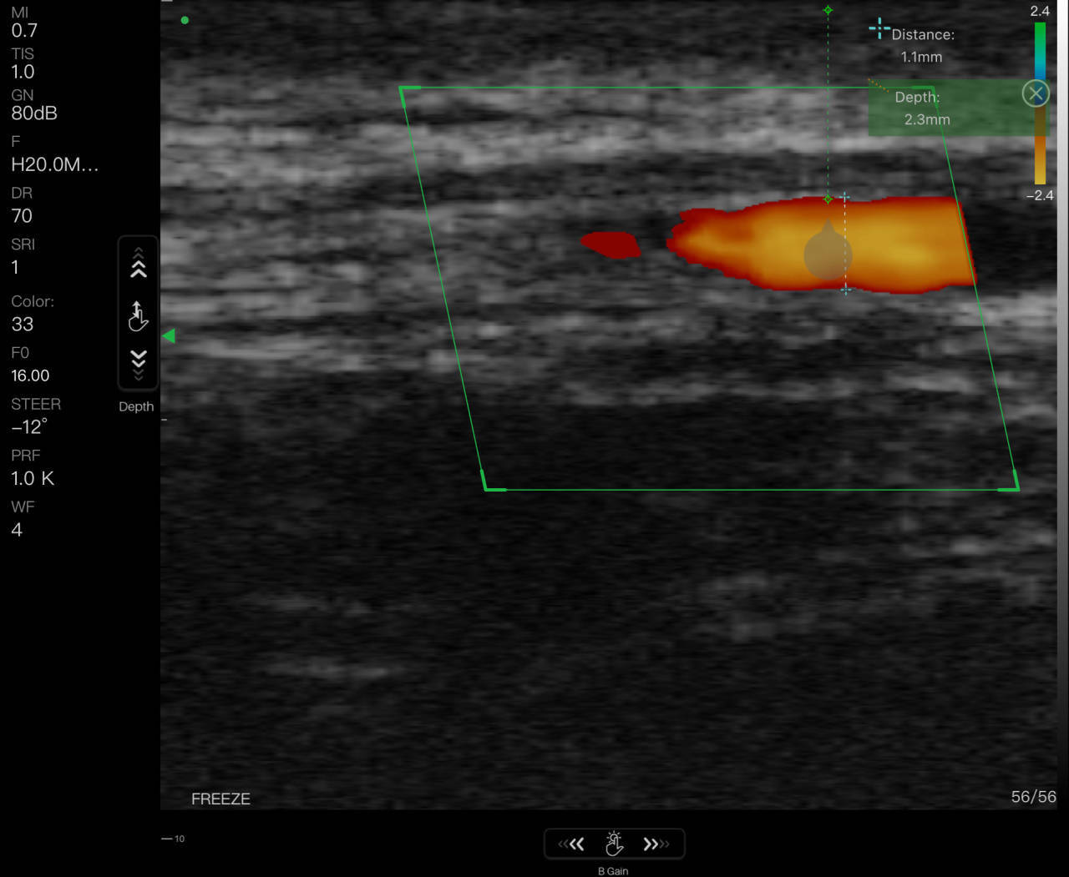

Product Show:
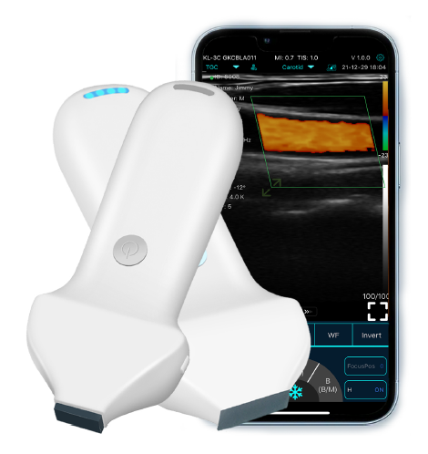

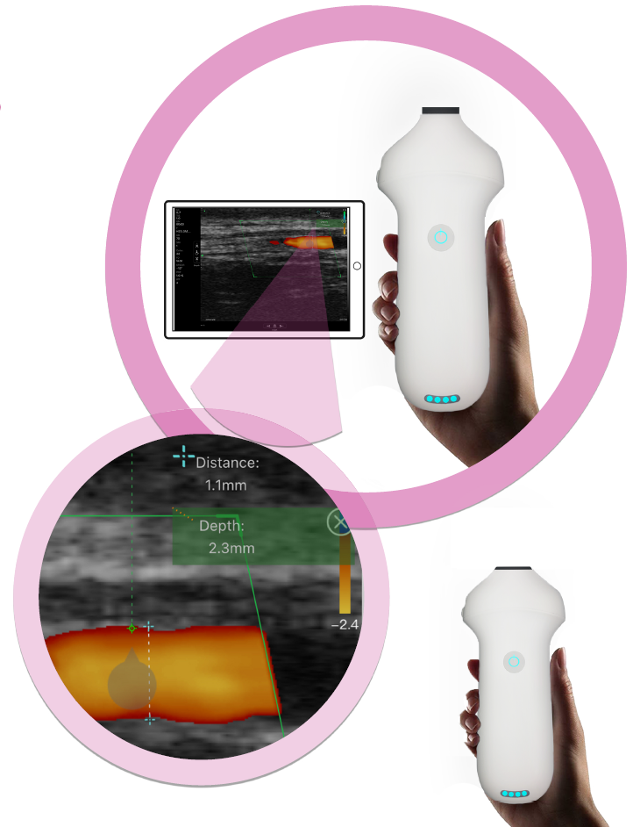

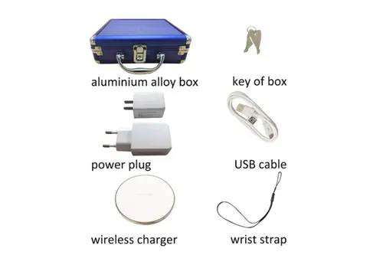


One stop Medical Solution Provider

POWER BY:


LANNX Bio&Med Co.,Ltd
Website: www.lannx.net
E-Mail: sale@lannx.net

