
Recording and Live Streaming Host【Premium Education (4+2)】
LB-8104M
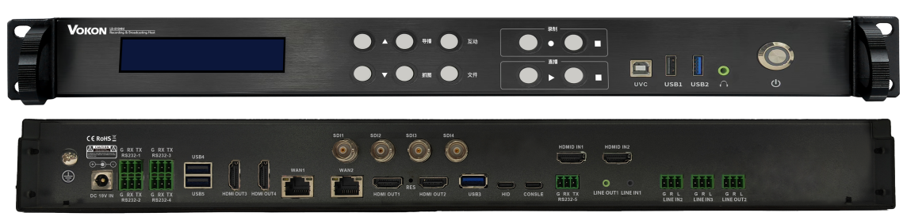

Functional description：
1.All-in-one terminal integrating audio/video capture, encoding/decoding, processing, recording, video-on-demand (VOD), live streaming, switching (production), remote interaction, and operation & maintenance management.
2.Supports both local and remote production with low latency and fast response; enables real-time preview and switching of at least 8 video channels (e.g., movie mode, PC1, PC2, teacher close-up, teacher wide shot, student close-up, student wide shot, interaction feed).
3.Supports simultaneous recording of up to 8 video channels, outputting standard MP4 or TS video files.
4.Features automatic repair of corrupted video files caused by unexpected power loss or system crashes.
5.Supports configurable recording duration (up to 24 hours per session), scheduled recording (up to 8 tasks), auto-recording on startup, and countdown-to-record functionality.
6.Enables loop recording: automatically deletes oldest recordings when storage is nearly full to ensure uninterrupted new recordings.
7.Recorded videos can be stored locally (on built-in 2TB HDD) or uploaded via FTP to a platform (with timed, real-time, or idle-upload modes).
8.Supports external USB storage; automatically copies completed recordings to connected USB drives.
9.Dual B/S and C/S management architecture; controllable via web interface, PC client, Android app, or local panel.
10.Built-in interactive conferencing supports up to 10 concurrent remote sites; scalable to over 10,000 participants when connected to an external interactive server.
11.Integrated HID control allows direct operation of connected PCs; supports UVC+UAC protocols for plug-and-play compatibility with mainstream operating systems and video conferencing software.
12.Supports on-screen graphics including subtitles, logos, OSD, intro/outro clips, live monitoring, and PTZ camera control.
13.Accepts multiple video input types: HDMI, SDI, network streams, and USB audio/video signals.
14.Offers multiple power-on methods: auto-start on power-up, scheduled boot, manual start; includes a hardware reset button for system recovery.

Technical specifications:

Model | LB-8104M
Physical Design | Standard 1U rack-mountable; metal chassis with fanless design; noise level < 26 dB
Operating System | Proprietary Chinese embedded OS (not Windows or Android); ARM multi-core processor; supports 24/7 operation
Display & Local UI | Built-in 3.2-inch LCD screen showing IP address, firmware version, disk usage, recording status, etc.  Dedicated front-panel buttons for quick access to IP, recording/live status, and one-touch start/stop control
Video Inputs | 2× HDMI (up to 4K)  4× SDI (1080p with embedded audio)  Also supports IP-based video streams and high-speed digital signals
Video Outputs | 4× HDMI (up to 4K)  1× UVC via USB Type-B
Audio Inputs | HDMI audio: 2 channels  Line-in stereo: 3 channels  UAC audio: 1 channel
Audio Outputs | HDMI audio: 4 channels  Line-out stereo: 3 channels  UAC audio: 1 channel
Audio Encoding | AAC codec, 48 kHz sampling rate for high-fidelity audio reproduction
Video Encoding | H.264 / H.265; adjustable bitrate from 512 kbps to 20 Mbps; resolution from 640×360 to 3840×2160 (4K)
Network Interfaces | 2× RJ45 ports (10/100/1000M auto-sensing)
Serial Control | 5× RS232 ports for connecting control panels, production keyboards, or central control systems
USB Ports | 5× USB Type-A  1× USB Type-B (for UVC+UAC)  2× USB Type-C
Storage | Built-in 2TB high-speed HDD; expandable storage; automatic file sync to USB flash drives upon recording completion
Power Supply | DC 19V, low-power and eco-friendly
Interactive Capability | Built-in support for 10-party interaction; scalable to ≥10,000 participants with external interactive server
Management & Control | Web browser, PC client, Android app, and local front-panel controls

www.vokontech.com VOKON Electronic Products （Guangzhou） Co.,Ltd.

