**"Water Fortress"**

**Water conservation, storage management practitioners**

1. range

1.1 Agricultural irrigation reservoirs

1.2 Drinking water project reservoirs

1.3 Greenhouse reservoirs

1.4 Fire fighting cisterns

The "Water Fortress" assembled cisterns are used in agricultural irrigation, greenhouses, forest firefighting, drinking water projects, sewage treatment, engineering water, etc.; fully utilising water resources in a rational way.

The assembled cistern is assembled by splicing aluminium-zinc-plated corrugated steel plate and polymer composite water bag, and all the parts are prefabricated by the factory and modularised; it is convenient for transportation in various ways. Steel plate material has a strong resistance to heat, low temperature, corrosion-resistant effect; water storage material one-piece moulding, anti-corrosion, mould, cold, anti-aging; equipment in the normal construction, use and regular maintenance under the design of the service life of up to 50 years, compared with the traditional water storage equipment service life is longer. It is a kind of economic, environmental protection, fast, safe and practical medium and large-scale water storage tank. The water storage capacity is 20m³-2000m³, which can meet the water demand of most industries. The material can be recycled for secondary use. (Note: Customised solutions are available according to the project site environment.)

**Conventional cisterns vs Water Fortress fitted cisterns**

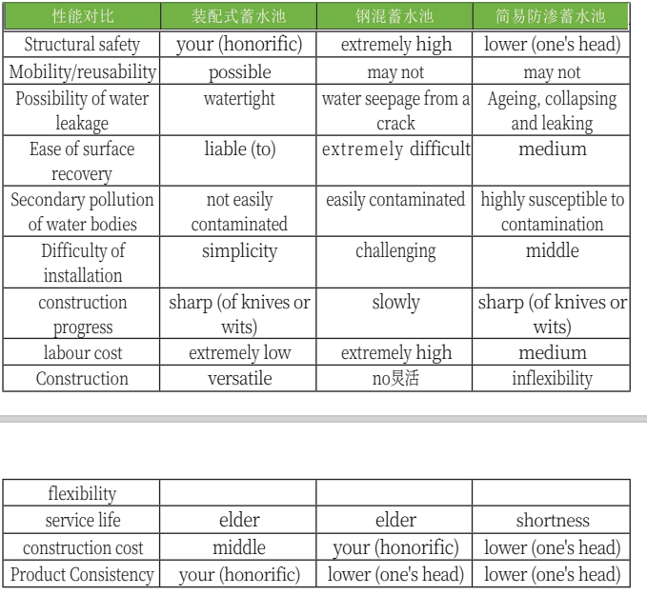

Several types of assembled cisterns

1. "Water Fortress" roofless assembled cisterns

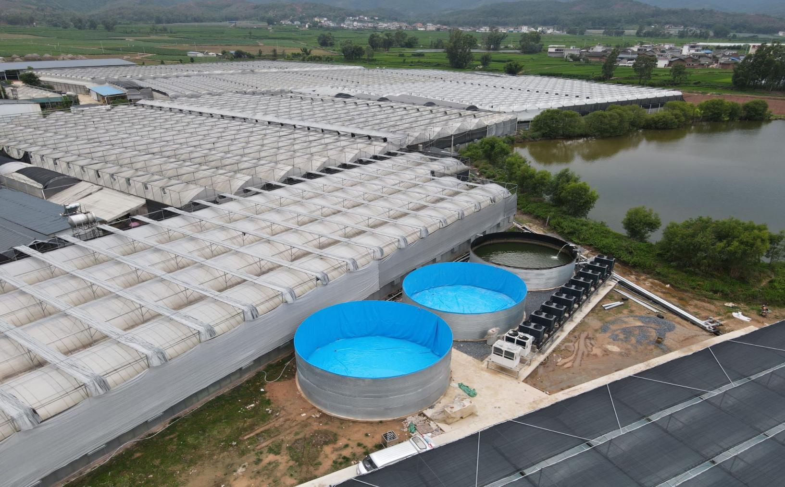

2. "Water Fortress" high-strength tensile-mesh assembled cisterns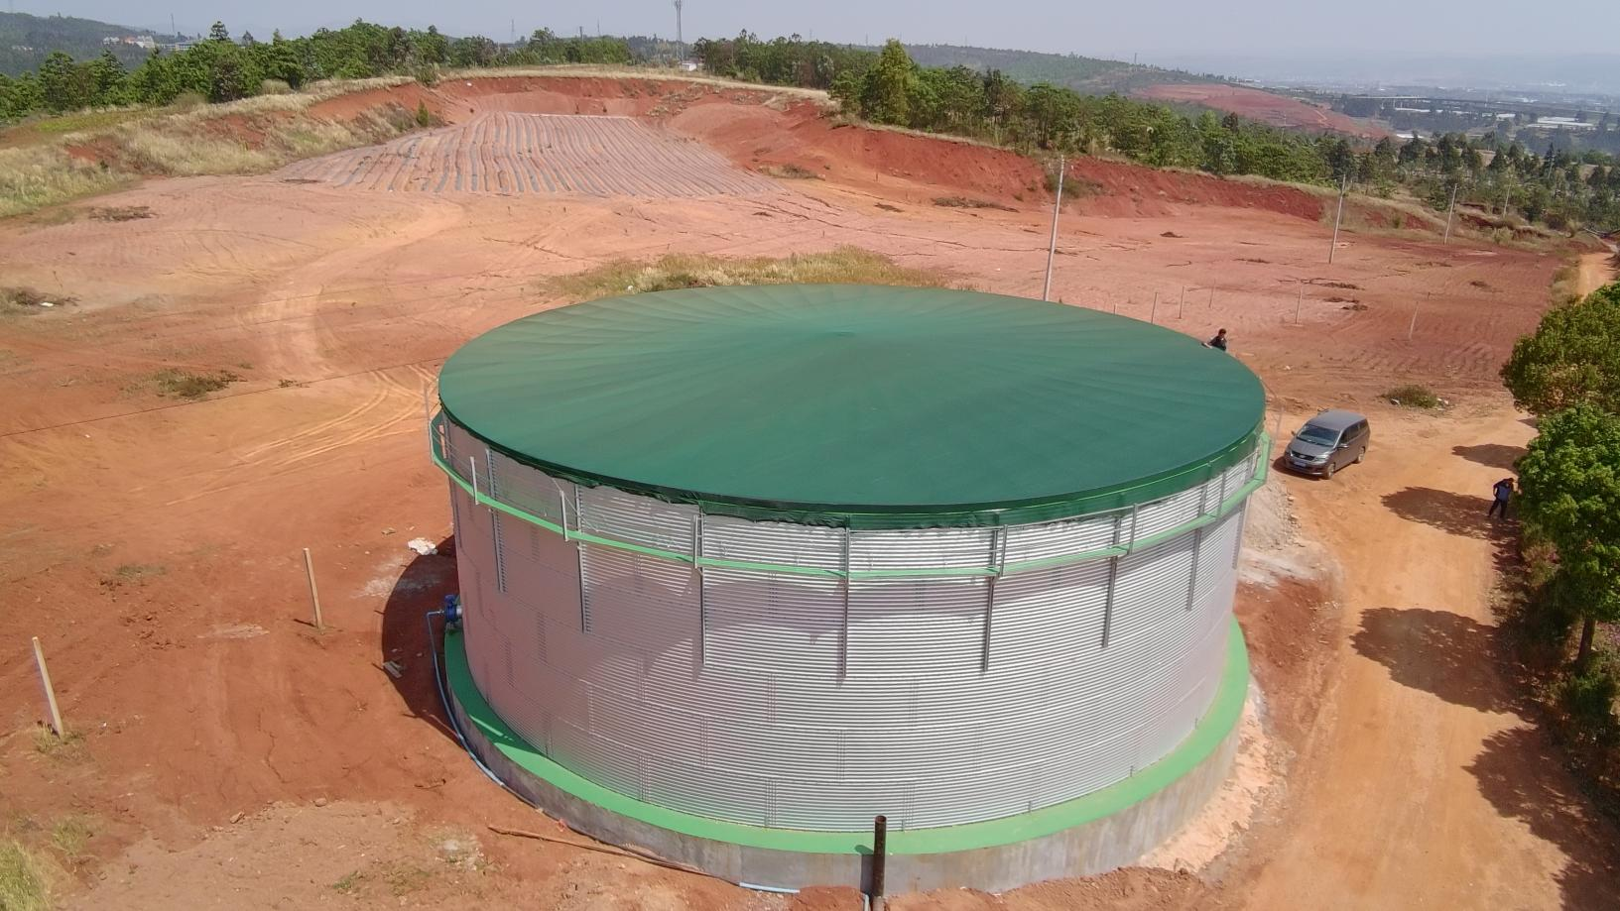

3. "Water Fortress" membrane-roofed assembled cisterns

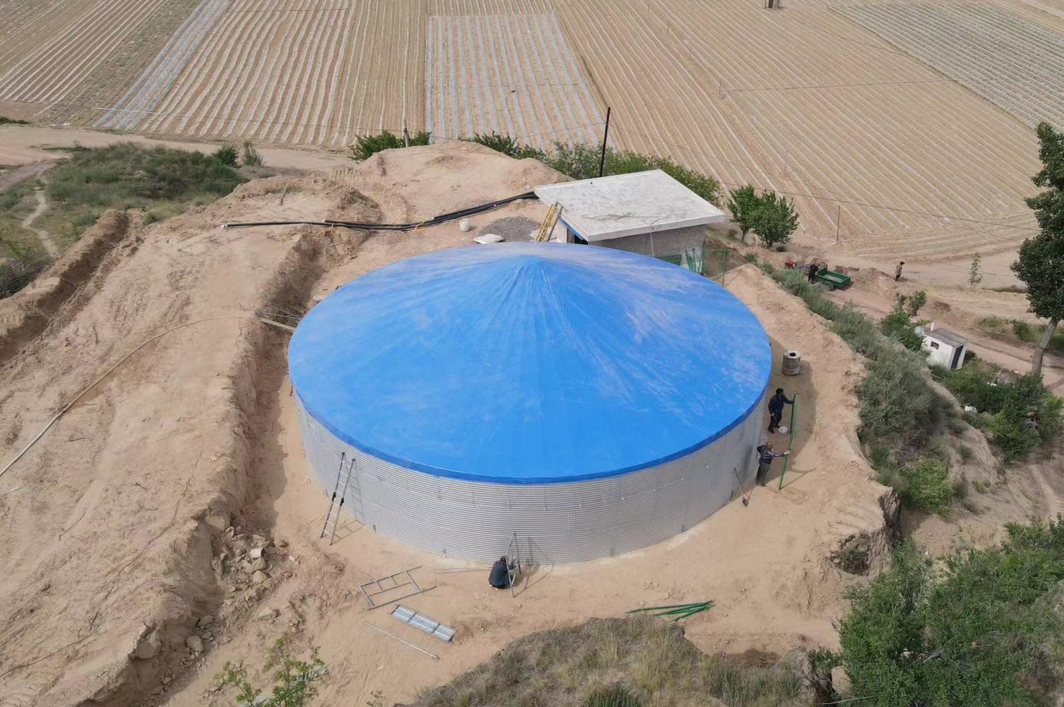

4. "Water Fortress" steel-topped assembled cisterns

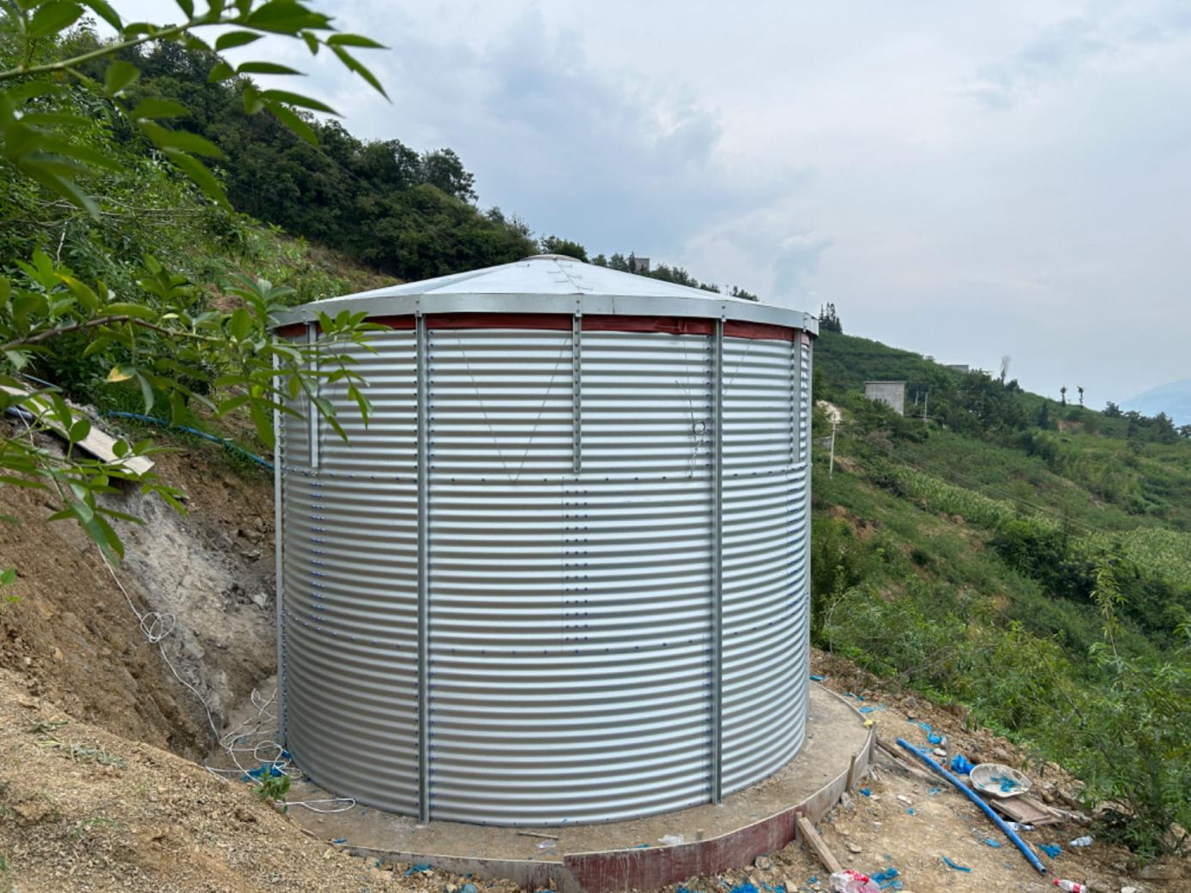

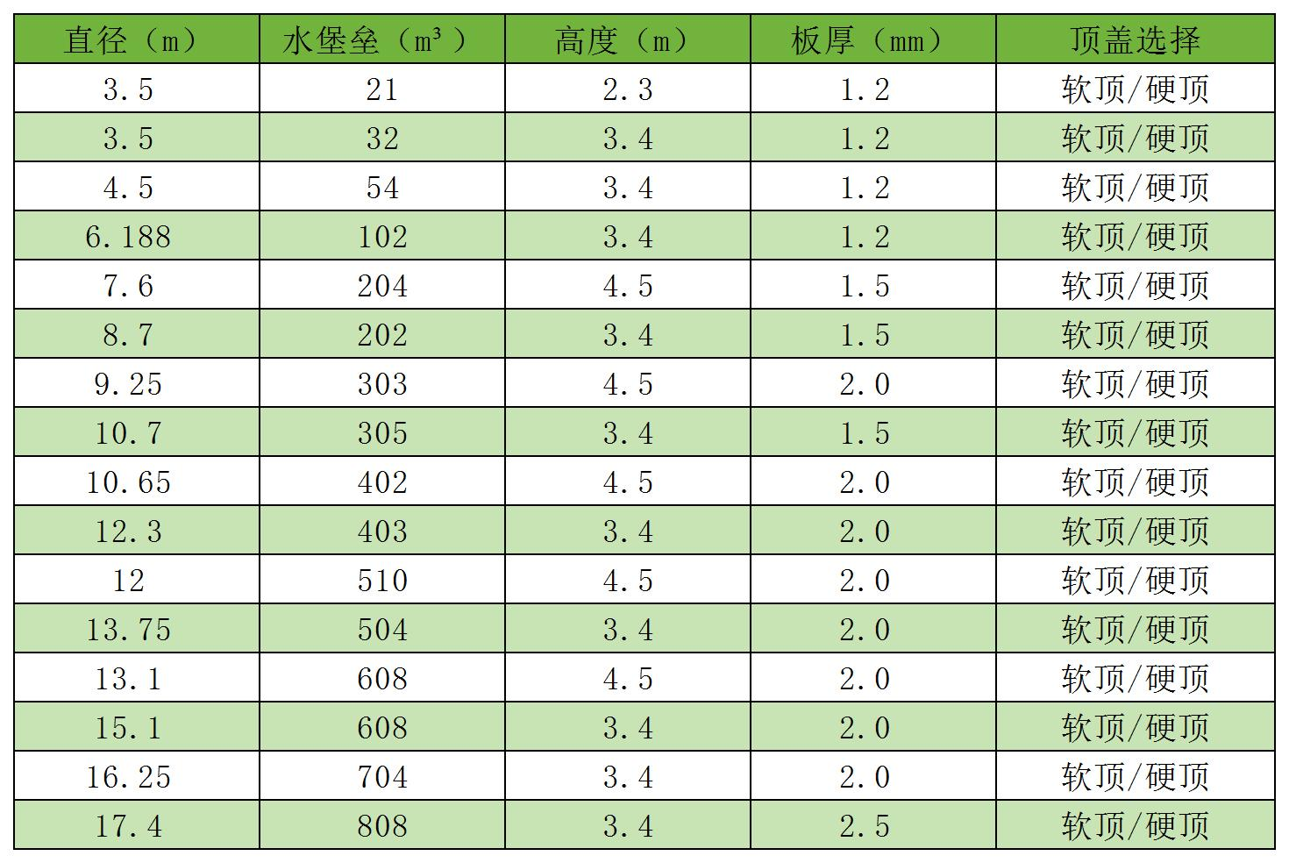"Water Fortress" assembled cistern conventional dimensions (recommended dimensions, can be customised)