**LCT5100WE SPECIFICATION**

**Model: LCT5100WE**

**Products Overview**



**LCT industrial touch panel 5000 series, a new generation of human-machine interface. low cost, aluminum alloy shell; motherboard threeanti-painting treatment, adapt to harsh environments. New molding,with more practicalbackward outlet; redesigned appearance, more beautiful; higher resolution models available.**

**Products Appearance**

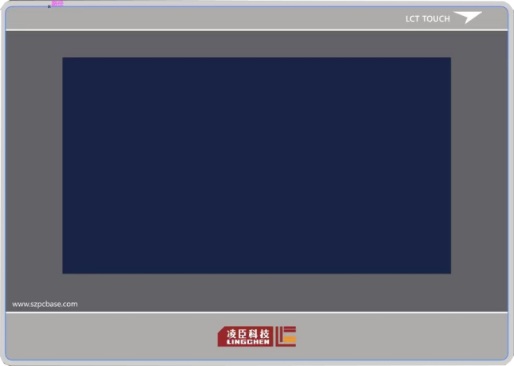

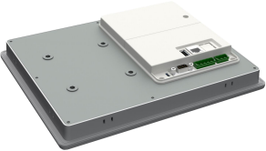

**Specification**



|  |  |  |
| --- | --- | --- |
| Hardware  Parameters | Display | 10.1” 16:9 TFT LCD touch Screen |
| LCD Viewing Angle  （T/B/L/R） | 85'/85'/85'/85' |
| Resolution | 1024×600 |
| Color | 16-bit |
| Brightness | 400 cd/m² |
| Backlight | LED |
| LCD Life | 50000 Hours |
| Touch Screen | 4-line Industrial Resistive Touch Screen |
| CPU | 4-core 1.2G Cortex-A53 Processor |
| Memory | 8GB FLASH+1GB DDR |
| RTC | Built-in |
| SD Card | Micro SD (TF) Card |
| Ethernet | 1-line 10M/100M adaptive |
| USB Ports | 1-USB Slave 2.0 port, 1-USB Host 2.0 port |
| Program  Downloading | USB Slave/U-disc /Ethernet |
| Serial  Communicatio n Port | COM1：RS232/RS485/RS422；  COM2：RS485/RS422  COM3：RS232 |
| Specifications | Rated Power | < 10W |
| Rated Voltage | DC24V,working range DC 9V~28V |
| Power  Protection | Protect from lightning and surging. |
| Allowable power-off time | < 5mS |
| Certification | CE: Comply with EN61000-6-2:2005, EN61000-6-4:2007 standards  RoHS: Comply with RoHS  EMC: Lightning surge±1KV, group pulse±2KV Electrostatic contact 4KV, air discharge:8KV |
| Environment Specifications | Working  Temperature | -10~60℃ |
| Storage  Temperature | -20~70℃ |
| UV-Anti | It prohibits working under strong ultra-violet radiation  environment ，such as direct sunshine. |

|  |  |  |
| --- | --- | --- |
|  | Environment Humidity | 10~90%RH (non-condensing) |
| Anti-vibration | 10~25Hz(X/Y/Z direction 2G/30minutes) |
| Cooling | Natural Cooling |
| Mechanical Parameters | Installation | Embedded Installation/VESA Installation |
| Protection | Front panel: comply to IP65 (based on embedded installation);  Back cover: comply to IP20 |
| Mechanical Structure | Aluminum alloy housing |
| Cutout Size | 260mm×202mm |
| Dimension | 274mm×214mm×39mm,thickness:26mm (without expansion) |
| Weight | About 1450g |

|  |  |  |
| --- | --- | --- |
| Power Terminals (Pin1~3 from left to Right) | | |
|  | Pin1 | DC24V |
| Pin2 | GND |
| Pin3 | FG |
| DB9 Serial ports (COM1/COM3) | | |
|  | Pin1 | Rx-(B） |
| Pin2 | RxD (COM1 RS232) |
| Pin3 | TxD (COM1 RS232) |
| Pin4 | Tx- |
| Pin5 | GND |
| Pin6 | Rx+(A) |
| Pin7 | RxD (COM3 RS232) |
| Pin8 | TxD (COM3 RS232) |
| Pin9 | Tx+ |
| COM2 | | |
|  | Pin1 | Rx+(A) |
| Pin2 | Rx-(B） |
| Pin3 | GND |
| Pin4 | Tx+ |
| Pin5 | Tx- |
| USB Host |  | |
|  | USB Type A | Used for connecting U-DISC, bar code scanner. |
| USB Slave | | |
|  | Micro USB | Used for program downloading and debugging. |

**Dimension LCT5100WE**

