**LCT5070WE SPECIFICATIONS**

**Model: LCT5070WE**

**Products Overview**



**LCT industrial touch panel 5000 series, a new generation of human-machine interface. low cost, industrial ABS plastic housing; motherboard three anti-painting treatment, adapt to harsh environments. New molding, with more practical backward outlet; redesigned appearance, more beautiful; higher resolution models available.**

**Products Appearance**



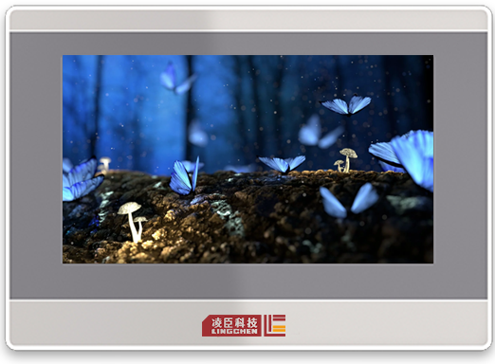

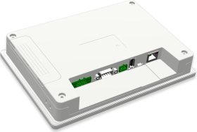

Specifications

|  |  |  |
| --- | --- | --- |
| Hardware  Parameters | Display | 7” 16:9 TFT LCD Screen |
| Resolution | 1024×600 |
| Color | 24-bit |
| Brightness | 350 cd/m² |
| Backlight | LED |
| LCD Life | 50000 hours |
| Touch Screen | 4-line Industrial Resistive HMI |
| CPU | 1G ARM Cortex-A8 |
| Memory | 256MB FLASH+512MB DDR3 |
| RTC | RTC Built-in |
| Ethernet | 1-line 10M/100M adaptive |
| SD Card | Support |
| USB Port | 1 USB Slave 2.0 Port,1 USB Host 2.0 Port |
| Program  Downloading | USB Slave/U-disc/Ethernet |
| Serial  Communication Port | COM1:RS232/RS485/RS422 COM2:RS485  COM3:RS232 |
| LCD Viewing Angle  （T/B/L/R） | 85'/85'/85'/85' |
| Specifications | Rated Power | < 10W |
| Rated Voltage | DC24V,working range DC 9V~28V |
| Power  Protection | With lightning and surging protection |
| Allowable  power-off time | < 5mS |
| Certifications | CE: Comply with EN61000-6-2:2005, EN61000-6-4:2007 standards  RoHS: Comply with RoHS  EMC: Lightning surge±1KV, group pulse±2KV Electrostatic contact 4KV, air discharge:8KV |
| Environment Requirement | Working  Temperature | 0~50℃ |
| Storage  Temperature | -20~60℃ |
| UV-Anti | It prohibits working under strong ultra-violet radiation  environment ， such as direct sunshine. |
| Environment | 10~90%RH (non-condensing) |



|  |  |  |
| --- | --- | --- |
|  | Humidity |  |
| Anti-vibration | 10~25Hz (X,Y,Z direction 2G/30 minutes） |
| Cooling | Natural Cooling |
| Mechanical Parameters | Protection | Front panel: comply to IP65 (based on embedded installation);  Back cover: comply to IP20 |
| Mechanical Structure | Engineering Plastics |
| Cutout Size | 192mm×138mm |
| Dimension | 204mm×145mm×33.8mm |
| Weight | About 560 g |

**Wiring Definition**

|  |  |  |  |  |
| --- | --- | --- | --- | --- |
|  | | | | |
| Power Terminals (Pin1~3 from left to Right) | | | | |
|  | | Pin1 | FG | |
| Pin2 | 0V | |
| Pin3 | DC24V | |
| DB9 Serial Port Terminals | | | | |
|  | | Definition | COM1 | COM3 |
| Pin1 | Rx-(B） (RS422/485-) |  |
| Pin2 | RxD (RS232) |  |
| Pin3 | TxD (RS232) |  |
| Pin4 | Tx- (RS422) |  |
| Pin5 | GND | |
| Pin6 | Rx+(A) (RS422/485+) |  |
| Pin7 |  | RxD (RS232) |
| Pin8 |  | TxD (RS232) |
| Pin9 | Tx+ (RS422) |  |
| 485 terminals (Pin1~2 from left to Right) | | | | |
|  |  | Pin1 | A+（COM2 RS485） | |
| Pin2 | B-（COM2 RS485） | |
| Ethernet Port | | | | |



|  |  |  |
| --- | --- | --- |
|  | RJ45 | Used for setting Ethernet with controllers or used for connecting server. |
| USB Host | | |
|  | USB Type A | Used for connecting U-disc and bar code  scanner etc. |
| USB Slave | | |
|  | Micro USB | Used for program downloading and debugging. |

**Dimension LCT5070WE**



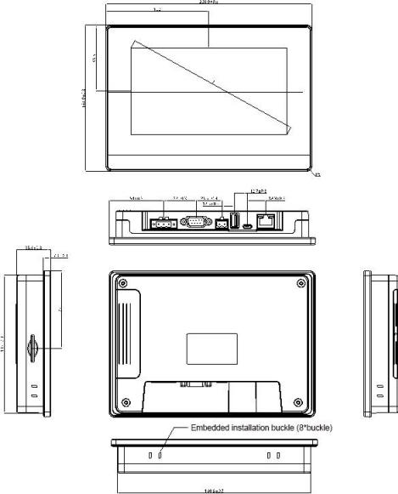

Embedded installation cutout size: 192*138（+1.5mm/-0.0mm）