|  |  |  |
| --- | --- | --- |
| Product Specification | | |
| Series Name | Fully Automatic Smart Lock(Face Version) | ef3e31372a9ac08c5b1321941f4112e |
| Product Model | WF 811 facial style |
| Available colour | Black、Grey |
| Sizes | Front plate：451*77*61mm（lnclude handle）  Back plate：451*77*61mm（lnclude handle） |
| Shell material | Aluminium die casting |
| Shell surface treatment process | Metal baking paint |
| Panel material | IML |
| Operating voltage | 6.8V~8.4V（lithium batteries） |  |
| Electricity supply | DC<7.4V lithium batteries 5000mAh lithium batteries | |
| Emergency power supply | Type-C Interface power supply | |
| Communication method | WIFI | |
| Fingerprint identification location | Front Panel Handle Outside | |
| Doorbell function | Support | |
| Mechanical quick opening function inside the door | Support | |
| Motor Emergency Unlock Knob | Not have | |
| Mechanical emergency unlocking function | Support | |
| Unlocking method | Password unlocking:capacity of 50groups,length of 6-12bits,support the virtual password function | |
| Fingerprint unlocking:capacity 100pieces | |
| Swipe card unlocking:capacity 50 | |
| Face unlocking:Capacity 50 | |
| Mechanical key unlocking:2 keys as standard | |
| Fingerprint/Password/Key/Card/WeChat Applet WIFI Remote/Face Recognition/4.5”Display | |
| Semiconductor fingerprint head specifications | Fingerprint head size:120*120 pixels,508dpi fingerprint head | |
| Fingerprint comparison time:＜1second | |
| Rejection rate:＜1 per cent | |
| Recognition rate:＜1 in 100,000 | |
| Finger use angle:360 degree all-round recognition | |
| User interaction | Mobile APP Setting lnterface | |
| Operating humidity | 45~90 per cent RH | |
| Operating temperature | -10 degrees Celsius-60 degrees Celsius | |
| Service life | ＞100,000 | |
| Antistatic test | Level 4 | |
| Immunity to strong eletromagnetic interference | support | |
| Suitable for door types and thicknesses | Door type:security doors,wooden doors and other entry doors；door thickness:45-120mm | |

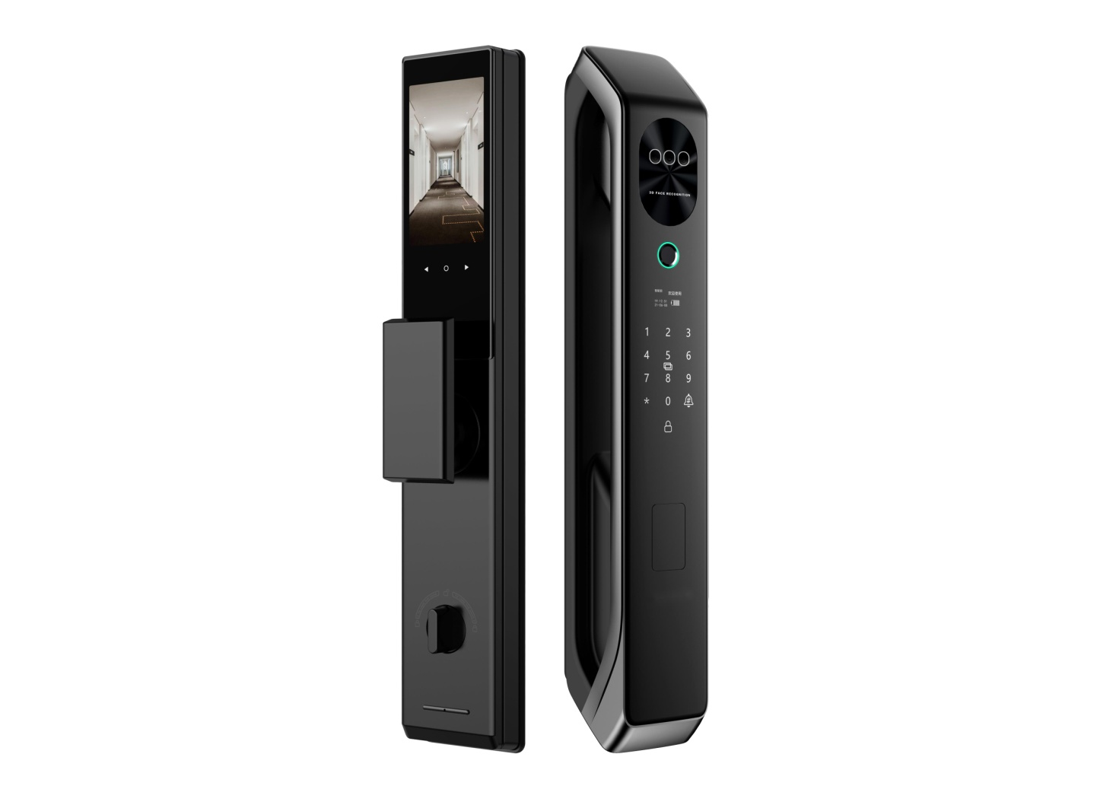The latest true 3D face recognition automatic smart lock

This fingerprint lock is equipped with fingerprint unlocking, password unlocking, key unlocking, card unlocking, wechat mini program WIFI remote unlocking, face recognition unlocking, and 4.5-inch display

Semiconductor fingerprint head specifications

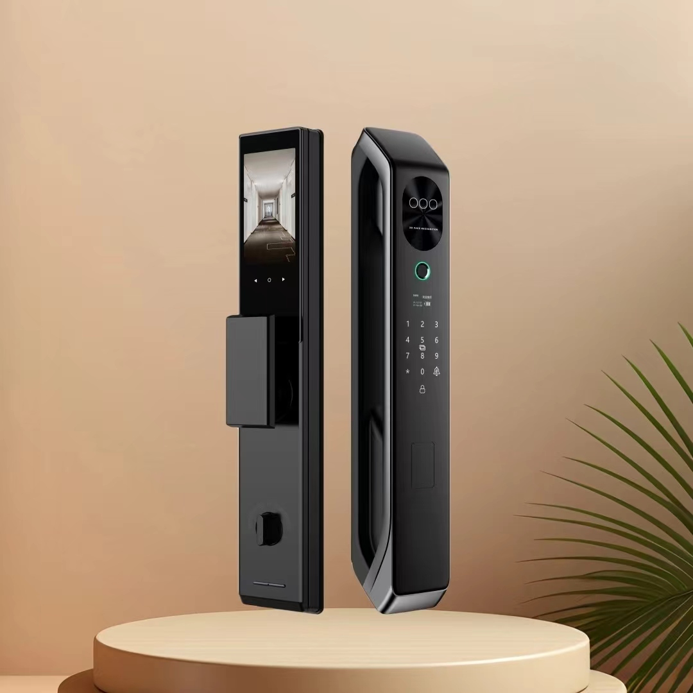Fingerprint head size: 120*120 pixels, 508dpi fingerprint head.