1，After the download is complete, unzip the file and run Aiosys.exe. // 下载完成后，解压，运行Aiosys.exe

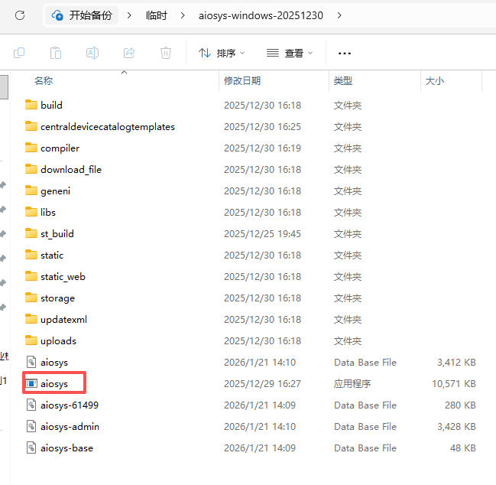
2，After the window pops up, wait a few seconds. The system will automatically launch your browser and open the AIOSYS website. Please be patient and allow all components to finish loading // 弹出的窗口后等待几秒会启动浏览器打开AIOSYS网站。请耐心等待以下内容全部运行
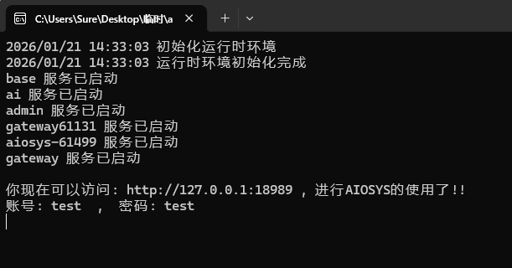
3，You can change the language on the pop-up page, or by visiting http://127.0.0.1:18989, and selecting the language option in the upper-right corner. // 可以在弹出页面，或访问http://127.0.0.1:18989，右上角设置语言
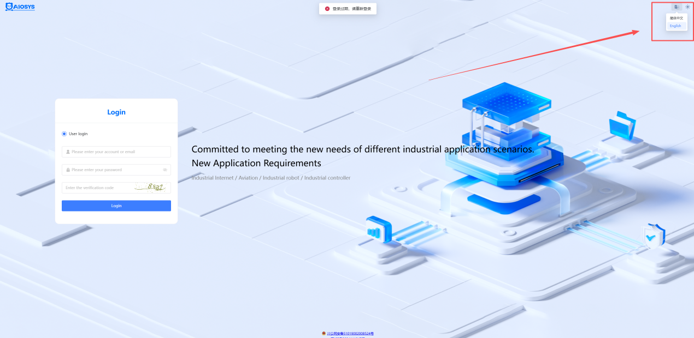
4，Enter the account：test
and password：test
to log in and start using the system normally.
// 输入账号：test 密码：test 可登录后正常使用

•
• .
•
•

