Melamine Plywood

Melamine Plywood board is made from plywood base board (poplar core, eucalyptus core, birch core) and melamine paper,Formed by high temperature hot pressing.Its biggest advantages are environmental protection, wear resistance, high temperature resistance, corrosion resistance, waterproof, simple and convenient, variety of patterns and colors ,etc. It is the first choice for customized furniture and indoor decoration
Size | 1220*2440mm, 1250*2500mm, 1230*2450mm
Thickness | 2mm,3mm,4mm,5mm,9mm,12mm,15mm,16mm,18mm,21mm,etc
Core material | Poplar ,Eucalyptus ,Birch ,Combi,etc
Face | Melamine paper,matt, high glossy, texture
Color | Solid color, wood grain, marble grain, cloth grain, etc.(We have melamine paper atlas,We have thousands of different color styles.We can provide customized service to produce the same color according to customer's samples)
Environmental grade | ENF, CARB P2, E0,E1,E2
Application | Home decoration, panel furniture, cabinet wardrobe, bathroom cabinet and other fields.

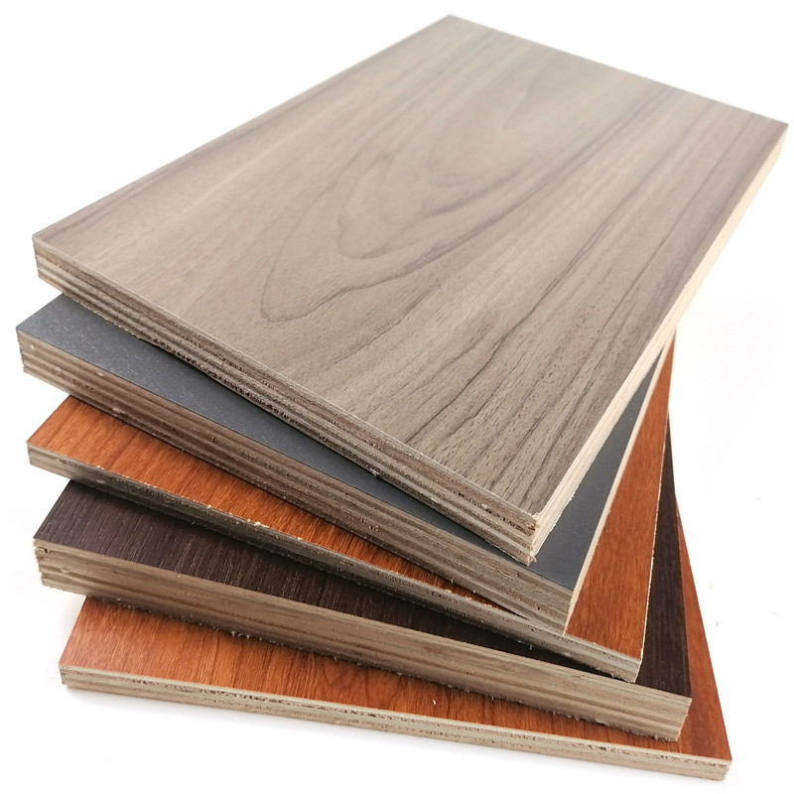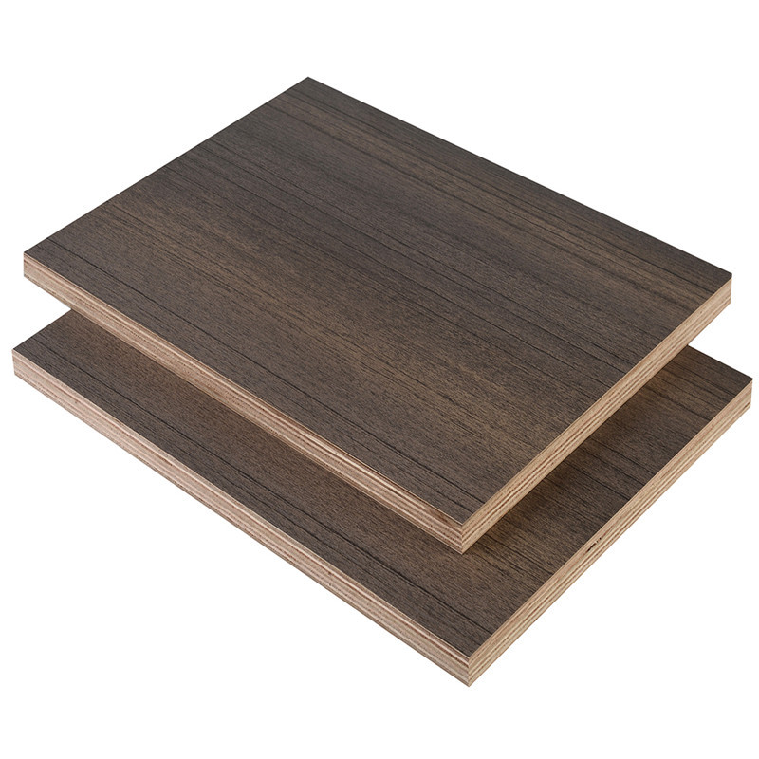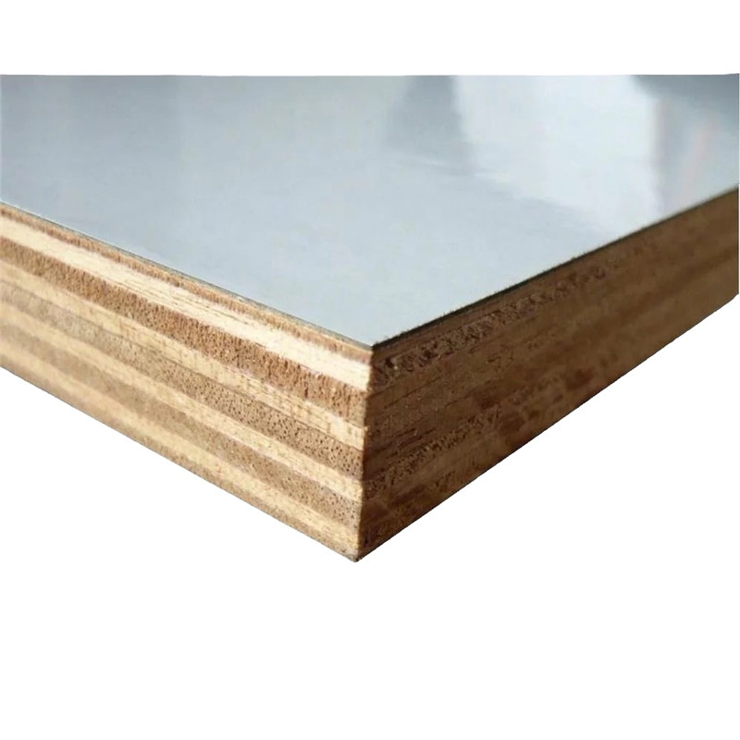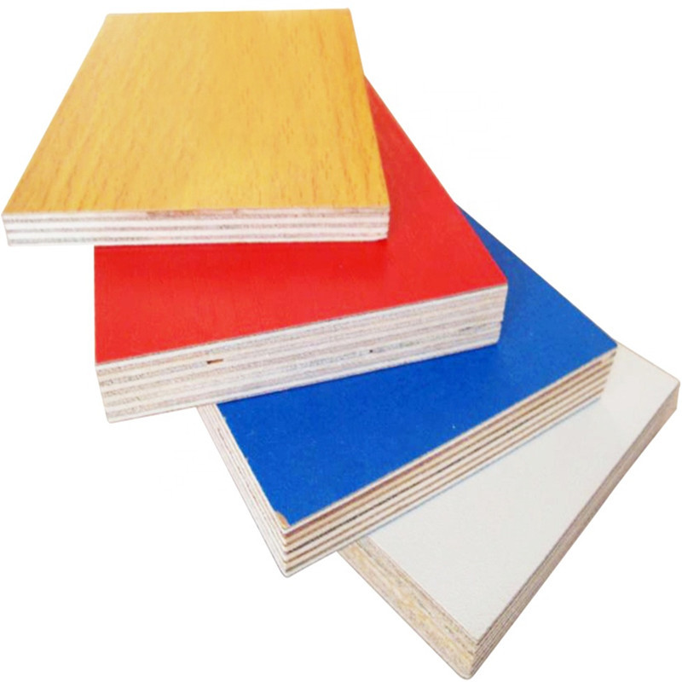
Melamine plywood Board is an engineered board with high quality and applicability, it is widely used for House decoration, Cupboard manufacturing, furniture manufacturing etc.Melamine plywood is a kind of decorative plywood made by plywood and melamine cover.Melamine plywood has been called Melamine board in some market.JIKEWOOD melamine plywood board use quality plywood core material and made by special producing skill.JIKEWOOD aim to produce the environmental protect melamine MDF plywood board as well as the strong and quality melamine plywood

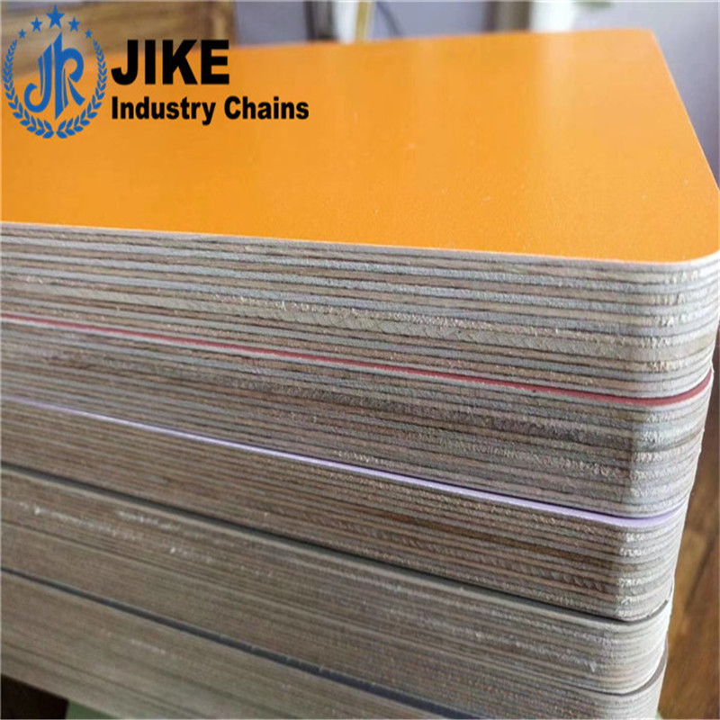

Melamine Plywood AdvantageUniform color and fine handle , Kinds colour or surface technics to chooseHigh bending strength and Strong nail holdingWithout warping and cracking,steady qualityMoisture-proof and tight construction.No ratten or decay.Low formaldehyde emissionEasy to nail ,saw cutting and drilling.can cut stones into various shapes according to construction needsPEFC certifiedFull range of sizes, support customization.Support OEM & ODM Service.JIKEWOOD melamine Plywood board Support customization UV, primed, stained or painted.

Application

JIKEWOOD Melamine plywood board combines a high quality plywood substrate with melamine Decortex surface bonded to both sides or one side.JIKEWOOD Melamine plywood offers both the strength and uniform core density of an plywood product with the smooth and beautiful finish of Melamine. With a clean, hard-wearing surface, melamine boards are suitable for internal cabinetry, draws or shelving.Melamine plywood board is used for a number of purposes including making kitchen cabinet, shelving, cupboards, wall units, wardrobes and furniture and much more. Due to its smooth and stable surface this plywood is also used for decorative wood or laminate veneers.JIKEWOOD also produce High Moisture Resistant plywood and Flame Retardant plywood for special use.
