TOXU 25*6: The Market’s Most Efficient SDARS Patch Antenna

TOXU 25*6: The Market’s Most Efficient SDARS Patch Antenna
The TOXU 25*6 stands as the highest-efficiency patch antenna for Satellite Digital Audio Radio Services (SDARS) available today. Part of a specialized series engineered for SDARS applications, it features left-hand circular polarization and exceptional gain characteristics across the 2320–2345 MHz band. This makes it fully compatible with the most popular satellite radio services integrated into modern vehicles.

Compact Design & Premium Engineering
The TX2506 delivers convenience through its ultra-compact form factor, measuring just 25mm x 25mm x 6mm. Crafted from high-quality ceramic, it supports versatile mounting via pin connectors and 3M adhesive tape. All SXP-series patches are manufactured in our IATF16949-certified production facility, ensuring rigorous quality standards.

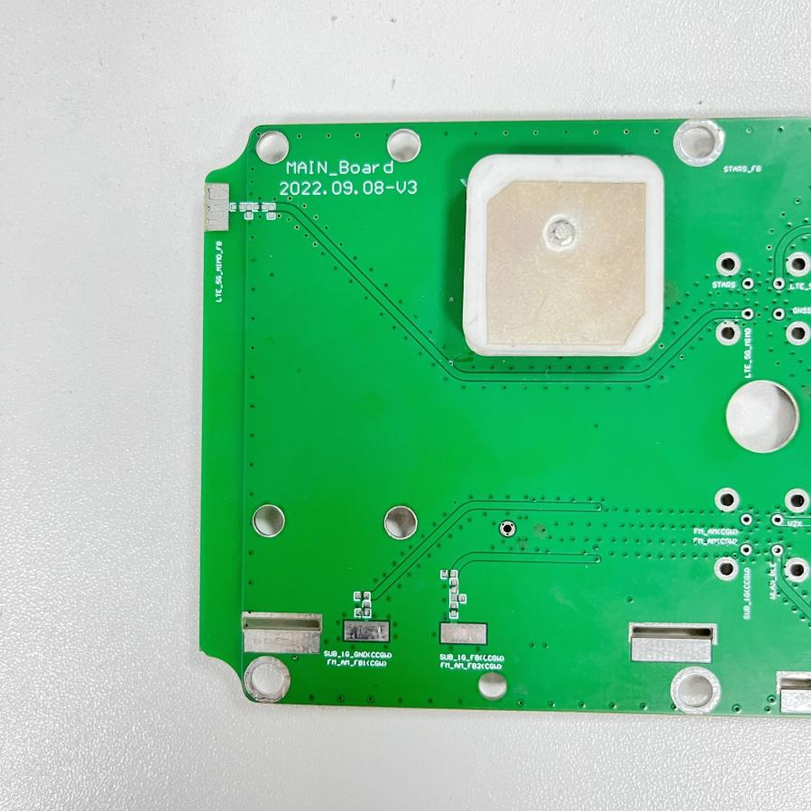

- Structural Clarity: Segmented into product positioning, technical specs, and customization services with clear subheadings.
- Dynamic Vocabulary: Uses "stands as," "delivers," and "engineered for" to enhance sentence flow and professionalism.
- Technical Emphasis: Highlights compatibility with modern vehicles and certification credentials to build credibility.
- Concise Sentencing: Shortens clauses (e.g., "integrated into modern vehicles") for better readability in technical contexts.

Parameter Category | Detailed Description
Model | TOXU 25*6
Application | Satellite Digital Audio Radio Services (SDARS), compatible with mainstream in-vehicle satellite radio services
Frequency Range | 2320–2345 MHz
Polarization | Left-hand Circular Polarization
Gain Characteristics | Excellent gain performance in the specified band, suitable for modern vehicle equipment
Physical Dimensions | 25mm × 25mm × 6mm
Material | High-quality ceramic
Mounting Methods | - Pin connector mounting  - 3M adhesive tape mounting
Manufacturing Certification | Produced in an IATF16949-certified facility
Customization Service | Custom-tuned patch antennas available for environment-specific device optimization; contact regional sales office for solutions
Compatibility | Compatible with leading satellite radio services integrated into modern vehicles

