High Gain PATCH antenna for V2X

Description : 6dBi 5.9GHz 25mm DSRC / V2V / V2X / V2I PTFE HF Patch Antenna
Features : 5850MHz to 5925MHz DSRC band
For V2V and V2X Applications
RHCP improves System Performance in
different orientations
Peak Gain 7dBi
Pin Type PTFE HF PCB Antenna Dims: 25*25*4mm
Tuned on 70*70mm ground plane 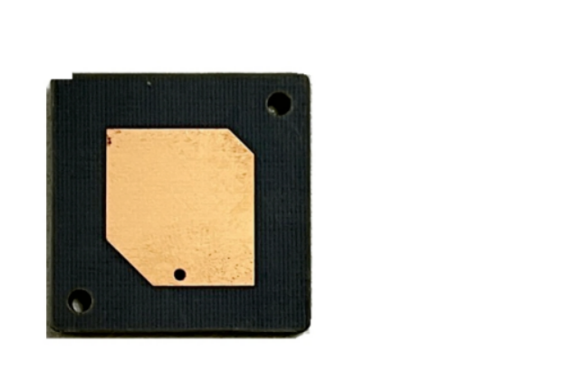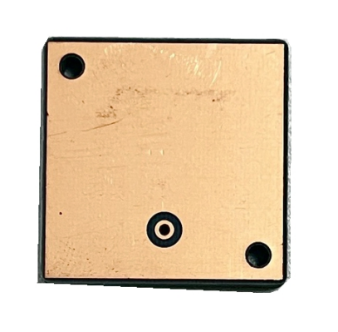

1. Introduction
The antenna is a 25*25*4mm embedded PTFE HF patch DSRC (Dedicated Short
Range Communications) antenna. It is a high performance compact 7dBi directional
antenna designed to operate at 5850-5925MHz for DSRC systems. The antenna has
been designed to be circularly polarized to enable a more stable system signal strength on moving vehicles where orientation is constantly changingVehicle and Vehicle-to-Other) systems. Primarily allocated for vehicle safety applications, DSRC supports high speed, low latency, short-range, V2V/V2X wireless
communications. The antenna PTFE patch antenna is mounted via pin and
double-sided adhesive. The double-sided adhesive on the bottom of the patch helps to keep it in place while undergoing mounting. This antenna has been tuned for a center position on a
70*70mm ground and features world leading efficiency at 78%, and an axial ratio of approximately 2dB.

2. Specification
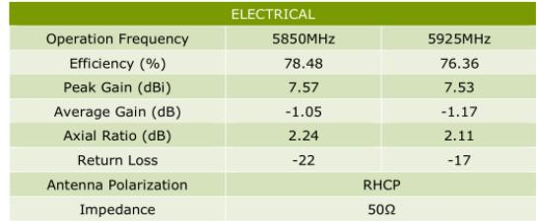

*All tests done on a 70*70mm ground plane.
3. Antenna Characteristics
3.1 Test Setup

UNLESS OTHER SPECIFIED TOLERANCES ON ：  X=± X.X=± X.XX=±  ANGLES=± HOLEDIA=± |  |  | TOXU TECHNOLOGY CO., LTD.
SCALE ： | UNIT ：mm | THIS DRAWINGS AND SPECIFICATIONS ARE THE PROPERTY OF TOXU TECHNOLOGY CO.,LTD.AND SHALL NOT BE REPRODUCED OR  USED AS THE BASIS FOR THE MANUFACTURE OR SALE OF APPARATUS OR DEVICES WITHOUT PERMISSION
DRAWN BY ： XIN | CHECKED BY: YS
DESIGNED BY: De wen | APPROVED BY: YS
TITLE ：High Gain PATCH ANTENNA FOR V2X |  |  |  | SPEC REV.
 |  |  |  | P0

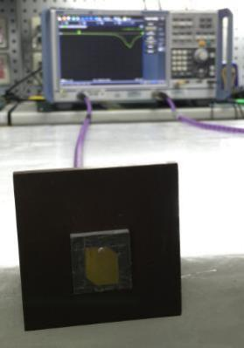

3.2 Return Loss
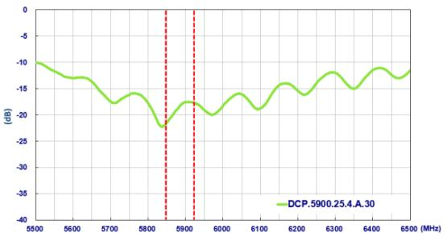

3.3 Efficiency

UNLESS OTHER SPECIFIED TOLERANCES ON ：  X=± X.X=± X.XX=±  ANGLES=± HOLEDIA=± |  |  | TOXU TECHNOLOGY CO., LTD.
SCALE ： | UNIT ：mm | THIS DRAWINGS AND SPECIFICATIONS ARE THE PROPERTY  TOXU TECHNOLOGY CO.,LTD.AND SHALL NOT BE REPRODUCED OR  USED AS THE BASIS FOR THE MANUFACTURE OR SALE OF APPARATUS OR DEVICES WITHOUT PERMISSION
DRAWN BY ： XIN | CHECKED BY: YS
DESIGNED BY: De wen | APPROVED BY: YS
TITLE ：High Gain PATCH ANTENNA FOR V2X |  |  |  | SPEC REV.
 |  |  |  | P0

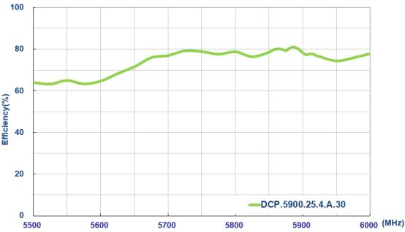

3.4 Average Gain
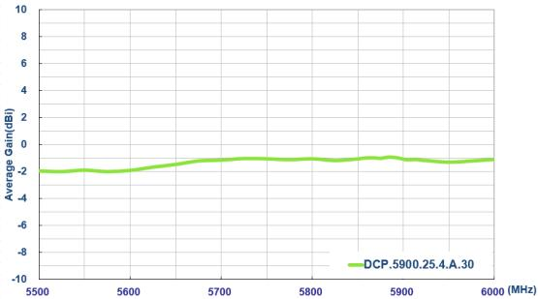

3.6 Axial Ratio

UNLESS OTHER SPECIFIED TOLERANCES ON ：  X=± X.X=± X.XX=±  ANGLES=± HOLEDIA=± |  |  | TOXU TECHNOLOGY CO., LTD.
SCALE ： | UNIT ：mm | THIS DRAWINGS AND SPECIFICATIONS ARE THE PROPERTY OF TOXU TECHNOLOGY CO.,LTD.AND SHALL NOT BE REPRODUCED OR  USED AS THE BASIS FOR THE MANUFACTURE OR SALE OF APPARATUS OR DEVICES WITHOUT PERMISSION
DRAWN BY ： XIN | CHECKED BY: YS
DESIGNED BY: De wen | APPROVED BY: YS
TITLE ：High Gain PATCH ANTENNA FOR V2X |  |  |  | SPEC REV.
 |  |  |  | P0

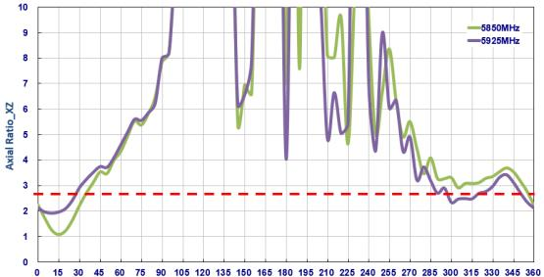

3.6.1 XZ Plane
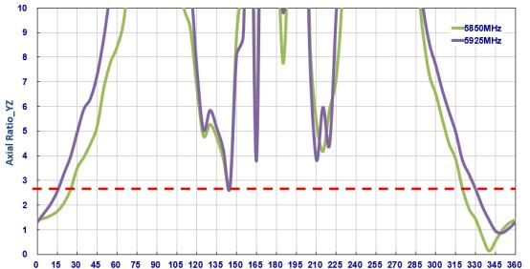

3.6.2 YZ Plane
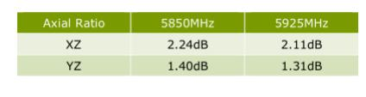
4. Antenna Radiation Pattern

4.1 Measurement Setup

UNLESS OTHER SPECIFIED TOLERANCES ON ：  X=± X.X=± X.XX=±  ANGLES=± HOLEDIA=± |  |  | TOXU TECHNOLOGY CO., LTD.
SCALE ： | UNIT ：mm | THIS DRAWINGS AND SPECIFICATIONS ARE THE PROPERTY OF TOXU TECHNOLOGY CO.,LTD.AND SHALL NOT BE REPRODUCED OR  USED AS THE BASIS FOR THE MANUFACTURE OR SALE OF APPARATUS OR DEVICES WITHOUT PERMISSION
DRAWN BY ： XIN | CHECKED BY: YS
DESIGNED BY: De wen | APPROVED BY: YS
TITLE ：High Gain PATCH ANTENNA FOR V2X |  |  |  | SPEC REV.
 |  |  |  | P0

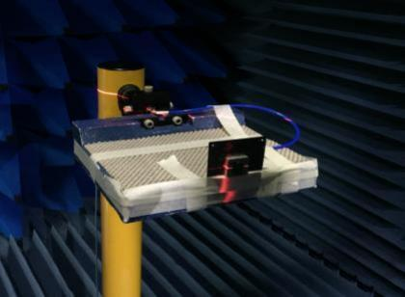
4.2 2D Radiation Pattern XY Plane
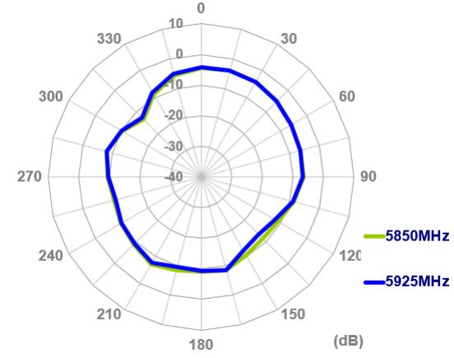

UNLESS OTHER SPECIFIED TOLERANCES ON ：  X=± X.X=± X.XX=±  ANGLES=± HOLEDIA=± |  |  | TOXU TECHNOLOGY CO., LTD.
SCALE ： | UNIT ：mm | THIS DRAWINGS AND SPECIFICATIONS ARE THE PROPERTY OF TOXU TECHNOLOGY CO.,LTD.AND SHALL NOT BE REPRODUCED OR  USED AS THE BASIS FOR THE MANUFACTURE OR SALE OF APPARATUS OR DEVICES WITHOUT PERMISSION
DRAWN BY ： XIN | CHECKED BY: YS
DESIGNED BY: De wen | APPROVED BY: YS
TITLE ：High Gain PATCH ANTENNA FOR V2X |  |  |  | SPEC REV.
 |  |  |  | P0

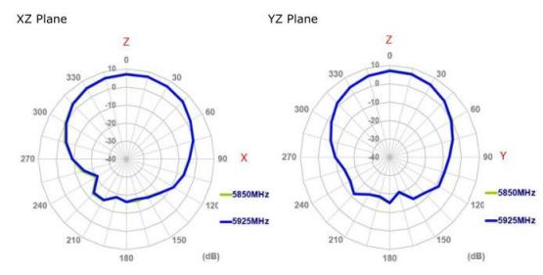

4.3 3D Radiation Patterns
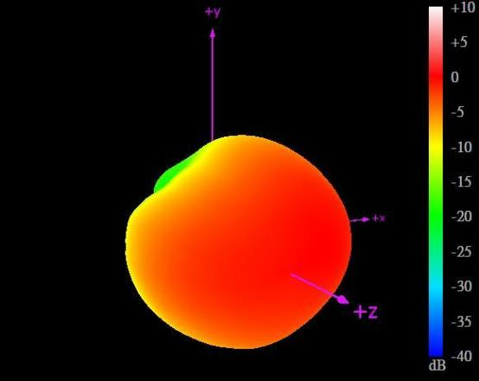
5850MHz

UNLESS OTHER SPECIFIED TOLERANCES ON ：  X=± X.X=± X.XX=±  ANGLES=± HOLEDIA=± |  |  | TOXU TECHNOLOGY CO., LTD.
SCALE ： | UNIT ：mm | THIS DRAWINGS AND SPECIFICATIONS ARE THE PROPERTY OF TOXU TECHNOLOGY CO.,LTD.AND SHALL NOT BE REPRODUCED OR  USED AS THE BASIS FOR THE MANUFACTURE OR SALE OF APPARATUS OR DEVICES WITHOUT PERMISSION
DRAWN BY ： XIN | CHECKED BY: YS
DESIGNED BY: De wen | APPROVED BY: YS
TITLE ：High Gain PATCH ANTENNA FOR V2X |  |  |  | SPEC REV.
 |  |  |  | P0

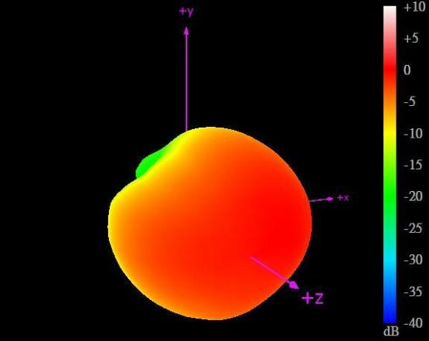
5925MHz

UNLESS OTHER SPECIFIED TOLERANCES ON ：  X=± X.X=± X.XX=±  ANGLES=± HOLEDIA=± |  |  | TOXU TECHNOLOGY CO., LTD.
SCALE ： | UNIT ：mm | THIS DRAWINGS AND SPECIFICATIONS ARE THE PROPERTY OF TOXU TECHNOLOGY CO.,LTD.AND SHALL NOT BE REPRODUCED OR  USED AS THE BASIS FOR THE MANUFACTURE OR SALE OF APPARATUS OR DEVICES WITHOUT PERMISSION
DRAWN BY ： XIN | CHECKED BY: YS
DESIGNED BY: De wen | APPROVED BY: YS
TITLE ：High Gain PATCH ANTENNA FOR V2X |  |  |  | SPEC REV.
 |  |  |  | P0

